- The financial market reaction to November's UK Budget was relatively muted, but we expect gilt yields to fall over the next couple of years as the Bank of England's Monetary Policy Committee gradually shifts to a more dovish policy stance.
- However, rising term premia suggest progress on bringing down yields is likely to be slow. The UK's fiscal position remains relatively poor and markets are being asked to digest very elevated levels of gilt issuance while the BoE continues its quantitative tightening programme. This also comes at a time when the global supply of highly-rated government bonds is increasing sharply.
- Meanwhile, structural changes in the pension sector point to weaker gilt demand from what has been a large and relatively price-inelastic purchaser, particularly at the long end. The emerging marginal buyer of gilts appears to be flightier, more price-sensitive, and favour shorter duration. So the Debt Management Office will continue to shift supply towards shorter maturities.
- This highlights the need for the UK government to develop a credible fiscal strategy focused on reducing borrowing and targeting politically challenging impediments to growth.
Following the UK government's efforts to prepare the ground beforehand, the financial market reaction to November's Budget was muted. The 10-year gilt yield has risen only modestly since the Budget, while spreads against US Treasuries and German bunds have narrowed slightly. Investors appear relatively content with the UK Chancellor's decision to more than double the fiscal headroom, while upward revisions to the government's net cash requirement and the Debt Management Office's gilt remit for 2025-2026 were smaller than expected.
We think the 10-year gilt yield will only fall modestly this year, before declining further through 2027 and 2028 (Chart 1). In our view, further disinflation and weak activity growth will lead the Bank of England's Monetary Policy Committee to cut Bank Rate further than markets expect, more than offsetting the upward pressure on yields from moving into a regime with structurally higher term premia.
Chart 1: We expect gilt yields to fall as short-term interest rate expectations continue to decline
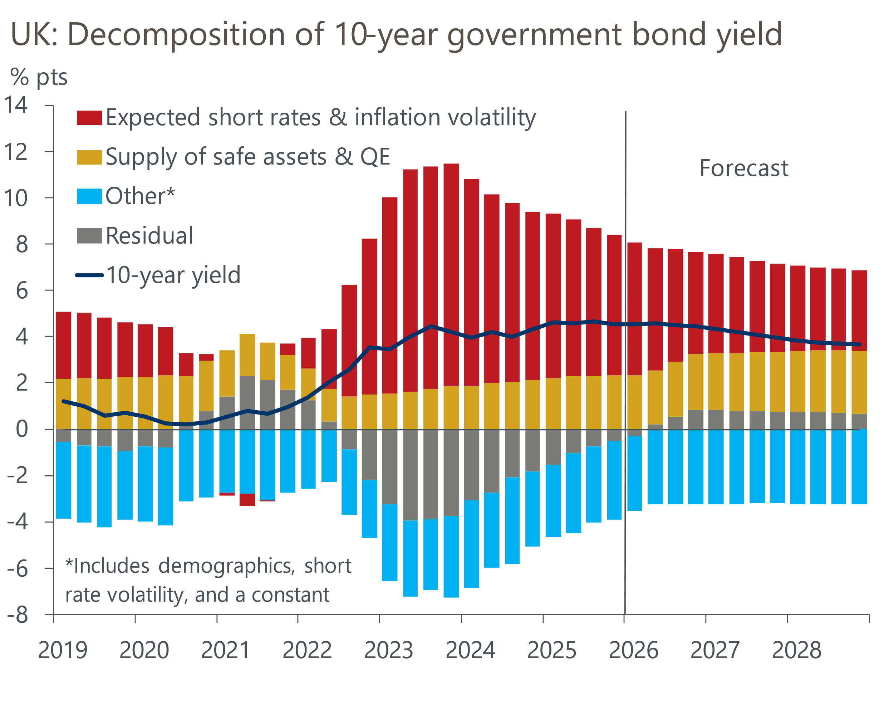
Sources: Oxford Economics, Haver Analytics

Gilt yields to benefit from lower short-term interest rate expectations
Our modelling framework decomposes 10-year government bond yields into a component that is explained by the expected future path for short-term interest rates, and factors that contribute to term premium – the additional yield investors demand for holding longer-term bonds. We find that short-term interest rate expectations are the primary driver of 10-year gilt yields – these have pushed yields up significantly since the BoE's rate hiking cycle began in late 2021.
But this dynamic is now unwinding, and we think three key factors could prompt the MPC to gradually shift to a more dovish stance over time. First, there are strong grounds to expect activity to surprise on the downside over the next couple of years. Our forecast that the economy will grow by 0.9% in 2026 and 1.4% in 2027 is much weaker than the BoE's forecast for growth of 1.3% and 1.6% in those years.
Our relative pessimism largely stems from the strength of domestic headwinds hindering an economy that is already struggling to find a sustainable growth driver. Following November's Budget, we estimate that fiscal policy will be tightened by 0.7% of potential GDP in FY2025-2026, 0.8% in FY2026-2027 and FY2027-2028. Recent labour market loosening likely has further to run, as the support from strong public sector job creation wanes. And over the next 18 months, a substantial minority of mortgagors will need to refinance cheap five-year fixed-rate mortgages taken out before mid-2022. We project that these borrowers face an increase in their mortgage rate of 200bps-250bps, which will significantly weigh on their spending power.
Second, we think the MPC is likely to see clearer evidence that inflationary pressures are cooling. October's private sector regular pay growth reading reached the upper bound of the 3%-3.5% range typically cited as being consistent with meeting the BoE's 2% inflation target in the medium term. Although some of the recent slowdown has been due to base effects, there's also evidence that pay growth will be dragged down further as conditions in the jobs market loosen. Together with base effects from the large increases in regulated prices and employers' national insurance contributions last April, softer pay growth should contribute to a steady cooling in services inflation through 2026.
Third, we see scope for MPC members to slowly coalesce around a lower estimate of the neutral policy rate. Financial market pricing implies that Bank Rate will settle around 3.5%. But the BoE's macro models, which are conditioned on inflation expectations that match the 2% target, point to a nominal neutral rate of around 3%. This is in line with the results from the BoE's latest Market Participants Survey. If activity growth underwhelms, inflation expectations fall back, and inflation settles close to target over the next couple of years, this would likely engender confidence among committee members that neutral is below 3.5%.
As a result, we expect Bank Rate to reach 3.25% by the end of this year and 3% by mid-2027, some 50bps below what current market pricing implies (Chart 2). This should help to gradually bring short-term rate expectations and gilt yields lower over the next couple of years.
Chart 2: We expect the MPC to cut Bank Rate to 3% by mid-2027, below market expectations
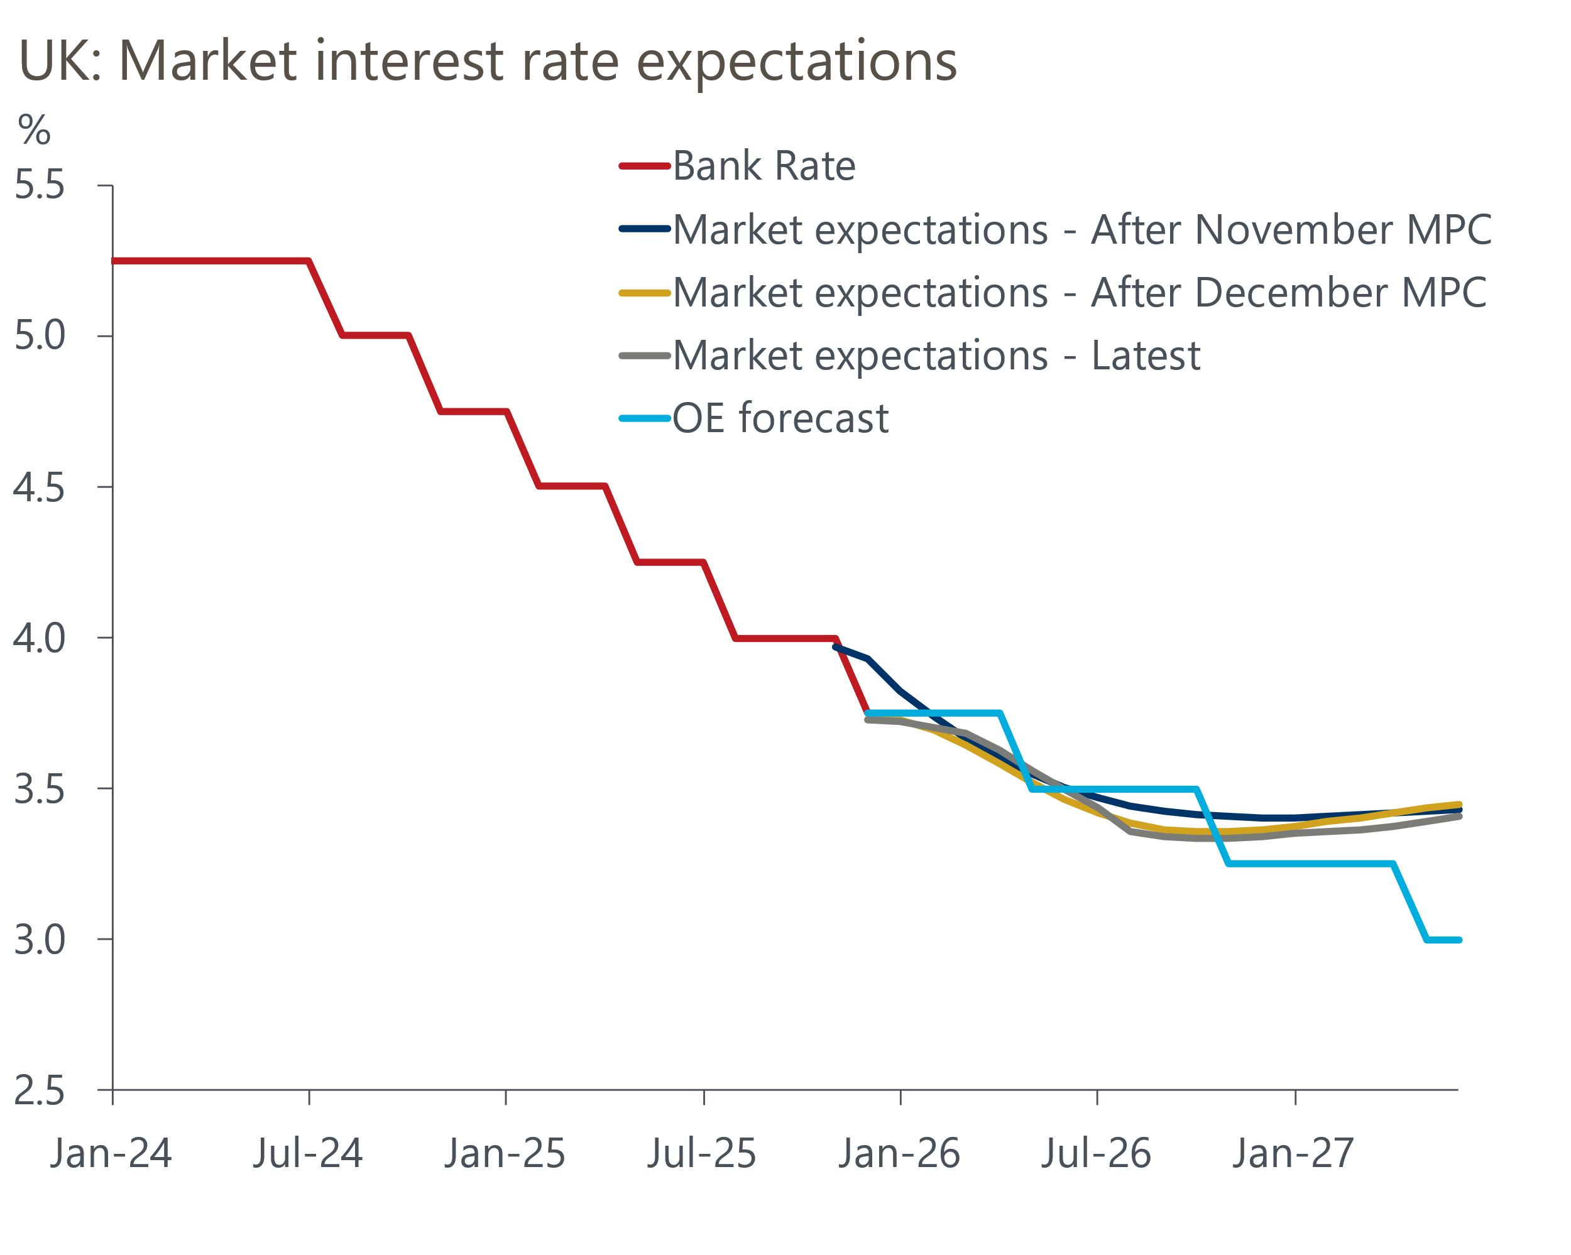
Sources: Oxford Economics, Haver Analytics

Rising gilt issuance, amid a global glut of safe assets
Although the 10-year yield will continue to be primarily driven by changes in short-term interest rate expectations, structural shifts in the supply and demand for gilts mean investors are now demanding more compensation – or higher risk premia – to buy UK government bonds.
Since the early 2000s, successive UK governments have run cyclically-adjusted budget deficits. But a sequence of supply shocks that have weighed on growth, unfavourable demographics, and higher interest rates, means the UK's budget deficit is now very high for a non-crisis period and is one of the largest in the G7. This has resulted in a hefty increase in gilt issuance over the past couple of years, which in turn has pushed up yields. As fiscal policy tightens, the OBR projects that net gilt issuance will fall only modestly to 4.4% of GDP in FY2025-2026 and 3.9% in FY2026-2027, which would still be well above the long-run pre-pandemic average (Chart 3).
Chart 3: Markets are being asked to absorb substantially more UK government debt
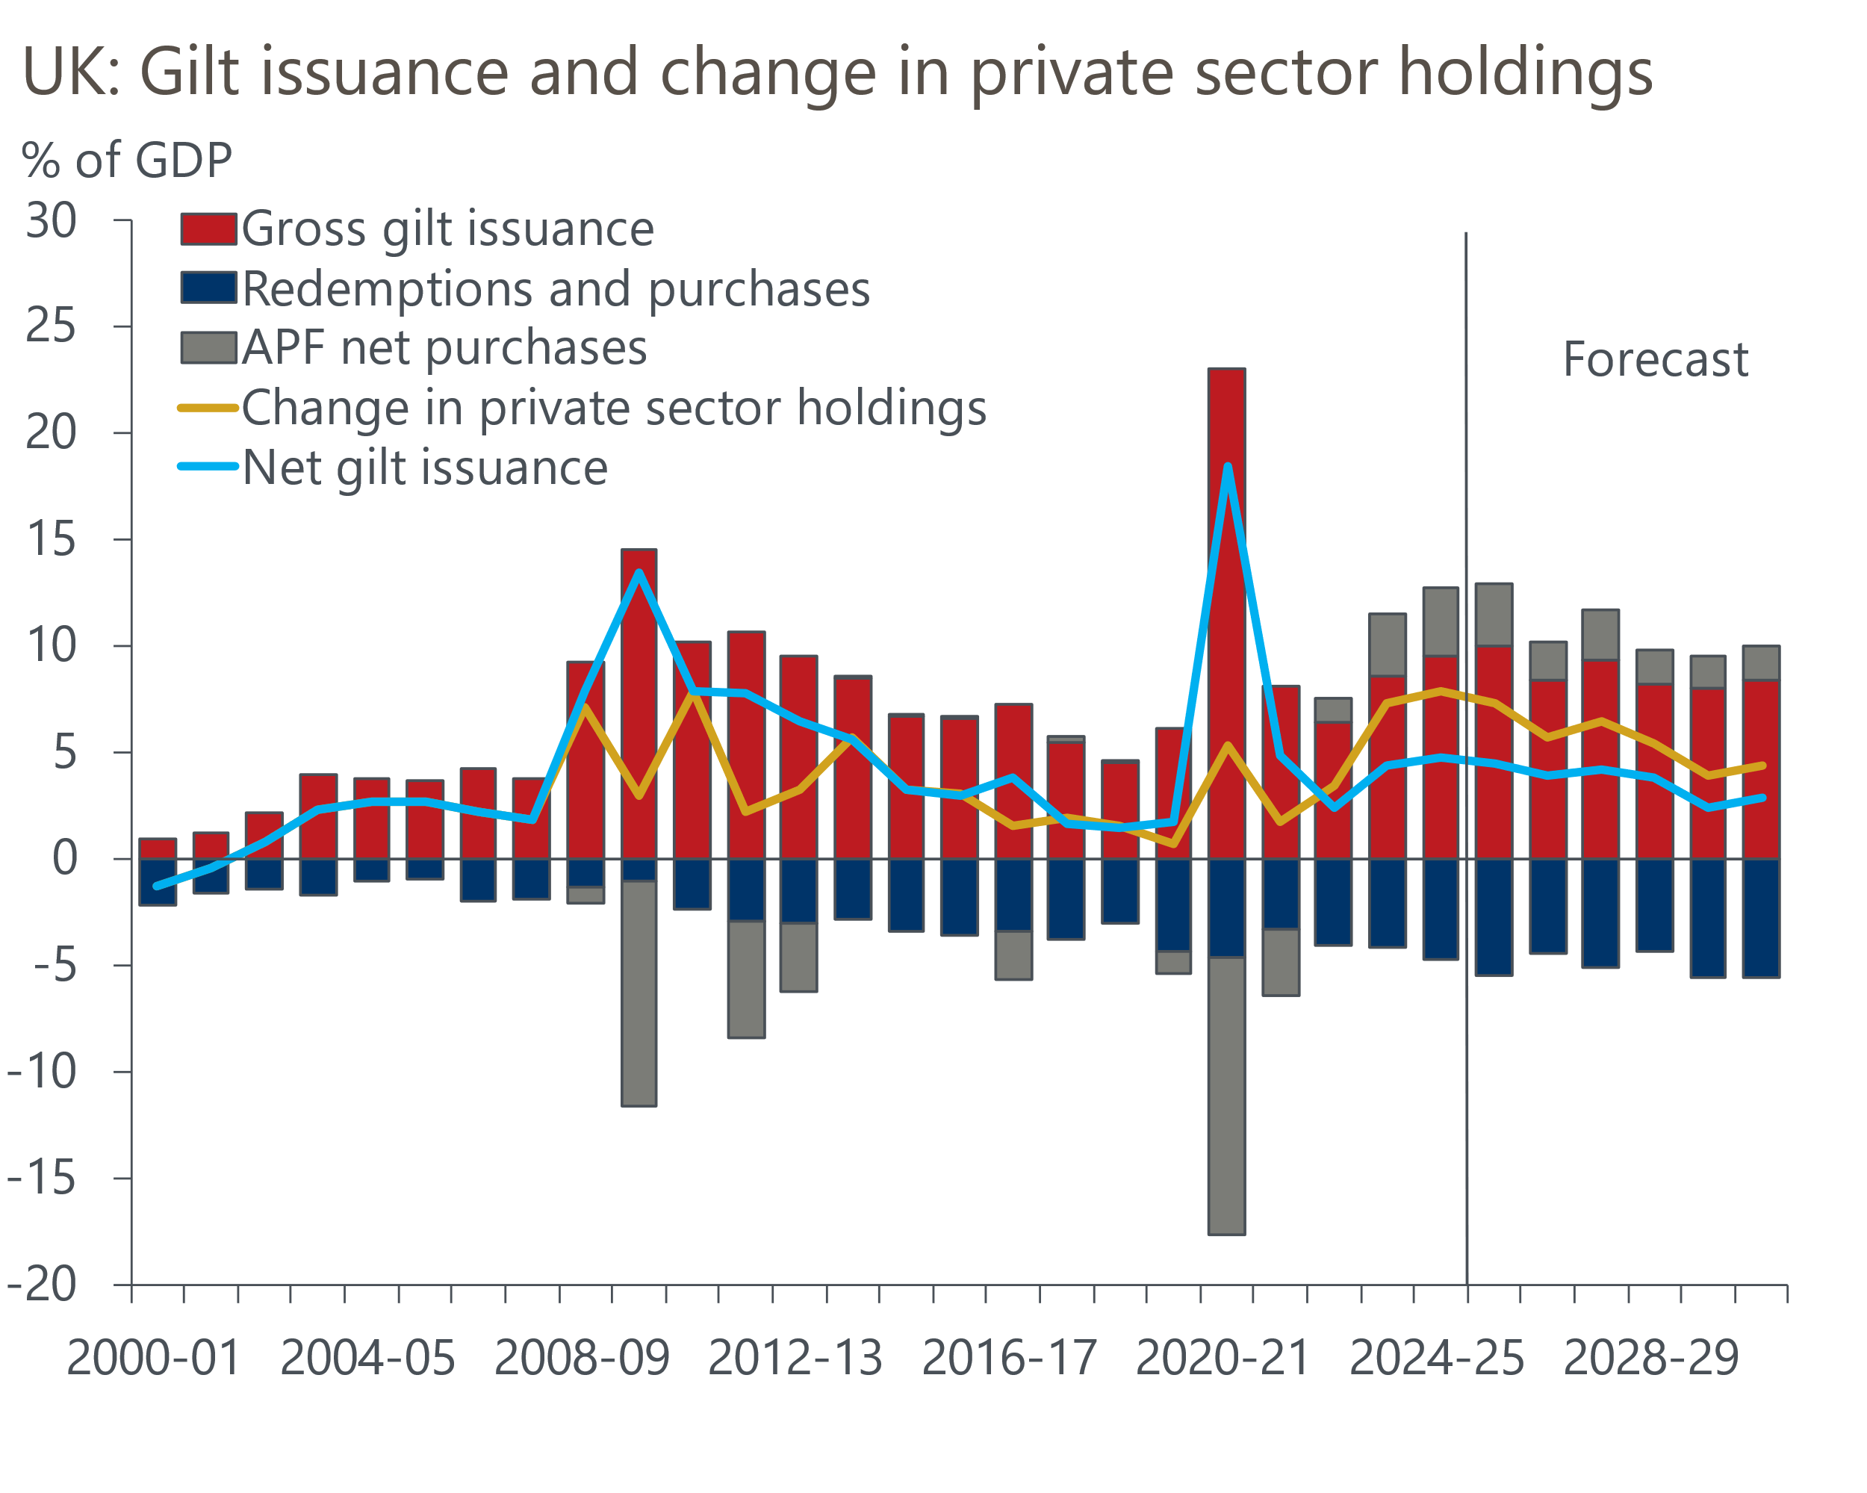
Sources: Office for Budget Responsibility, Debt Management Office
Prior to 2021, heavy purchases of gilts by the BoE limited the level of issuance that had to be absorbed by private sector market participants. This depressed term premia. But we're now in a period of heavier issuance as the BoE's purchases are being unwound via its quantitative tightening programme. This means markets have a much greater supply of gilts to digest than in the past (Chart 3). So for markets to clear, investors are now demanding higher yields to compensate for this additional burden.
As the BoE conducts QT in a way that doesn't communicate changes to future Bank Rate, any impact of QT on gilt yields will come through higher term premia. The BoE's annual review of its QT programme argued that the impact of QT on term premia had resulted in a 15bp-25bp increase in yields since 2022. Looking ahead, the BoE's latest MaP survey suggests active gilt sales will only comprise a small part of QT over the coming years, so any additional upward pressure on term premia is likely to be limited.
What's more, the UK hasn't been alone in delivering a large increase in government bond issuance. Since 2022, the global supply of highly-rated government debt has risen sharply. By 2030, we expect the supply of 'safe' government bonds, net of central bank flows, to rise by 4.6% of global GDP. That would bring net supply to 33.1% of global GDP – much higher than the levels seen since the global financial crisis (Chart 4). With high issuance a global phenomenon, investors are increasingly requiring higher risk premia for holding long-term debt, particularly for economies where concerns about fiscal sustainability linger.
Chart 4: The net supply of safe globally is set to rise considerably
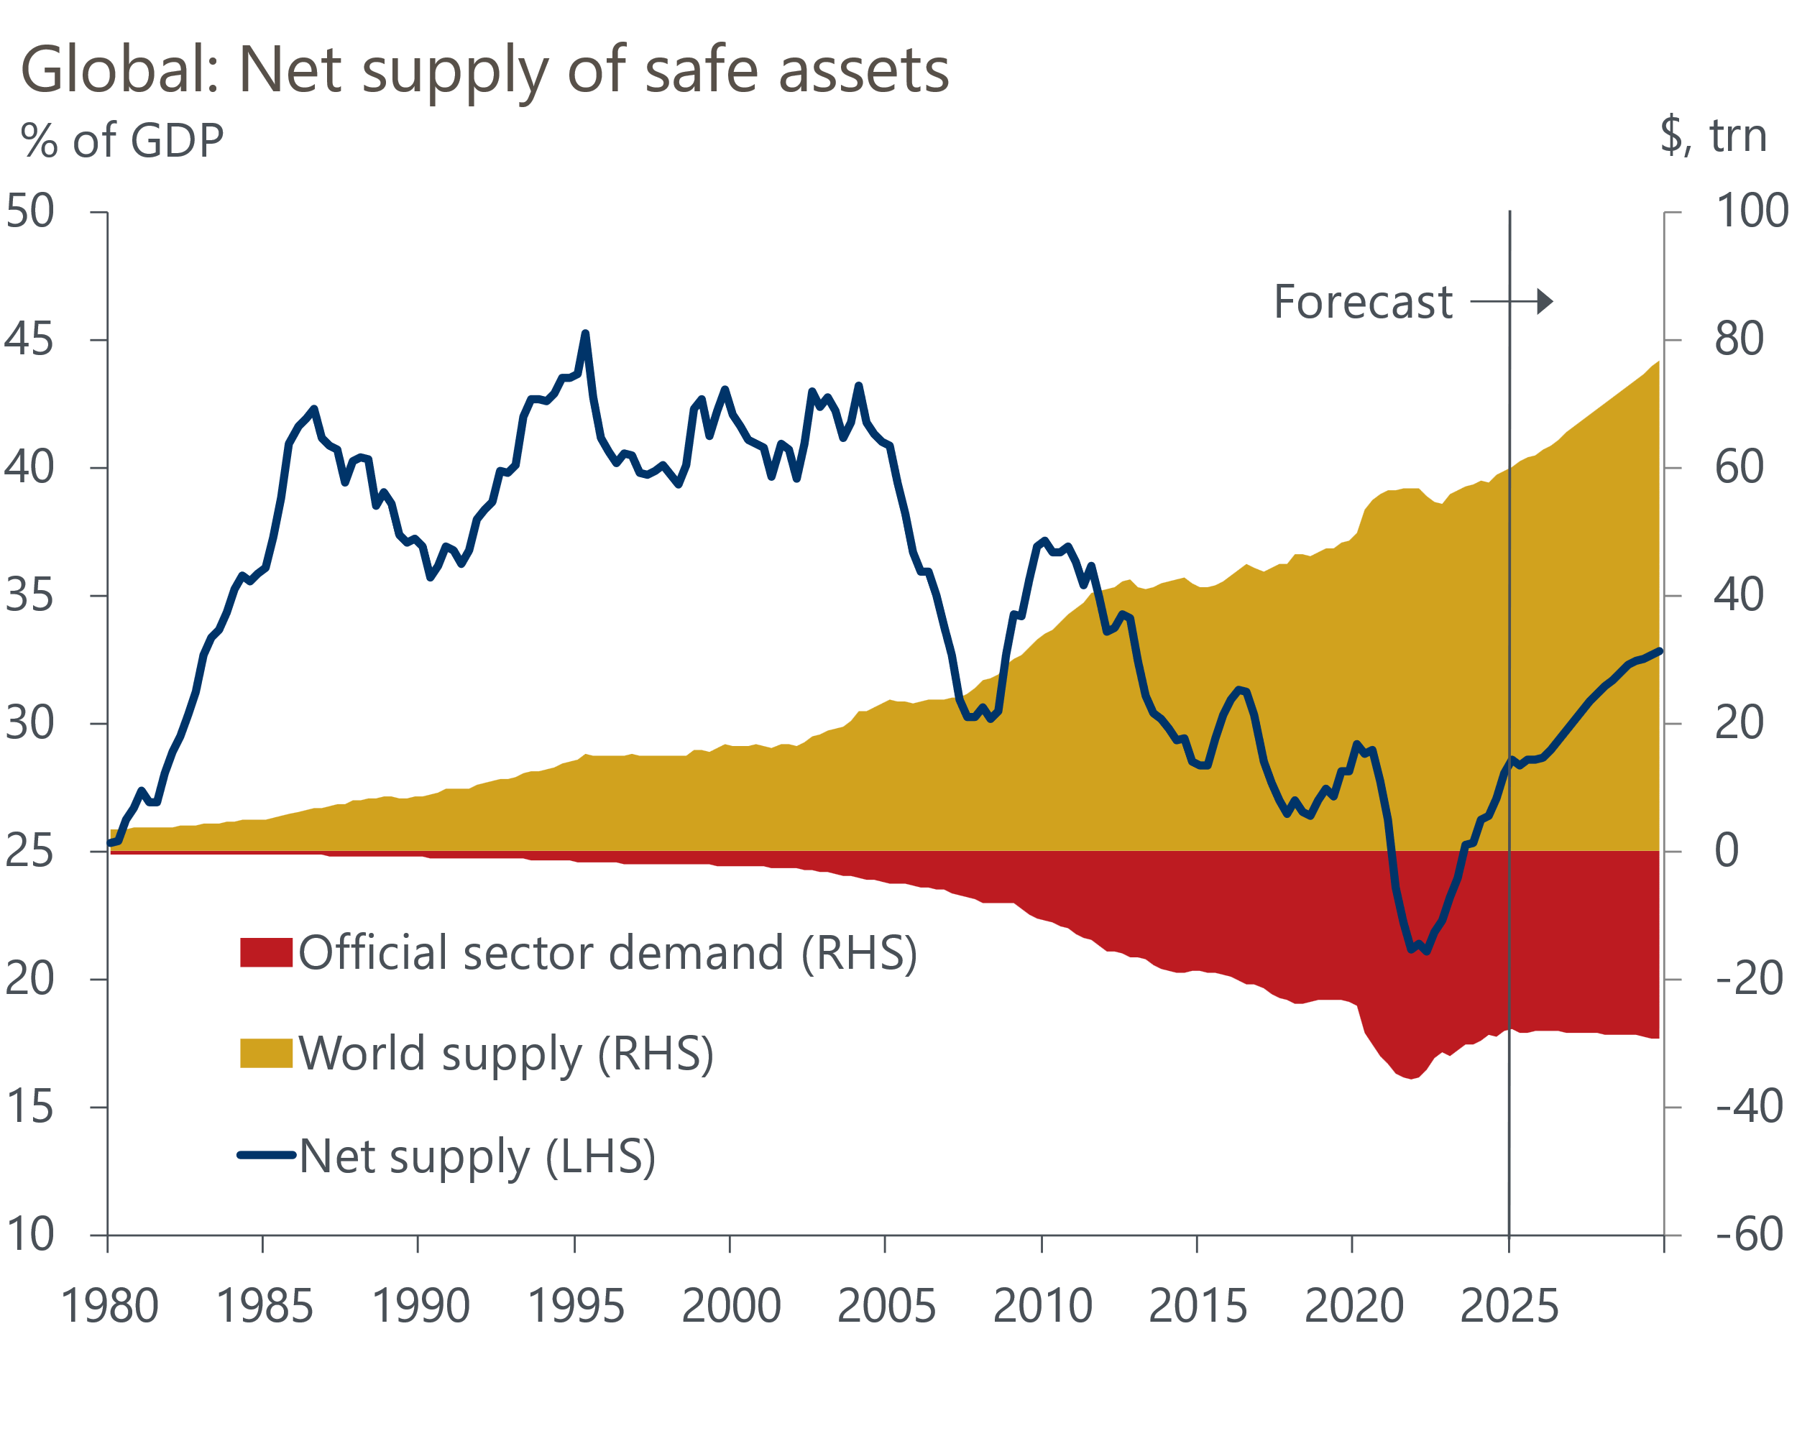
Sources: Oxford Economics, Haver Analytics

Rotating sector and maturity demand point to gilt buyers becoming more price-sensitive
UK defined benefit (DB) pension schemes have traditionally been major price-inelastic purchasers of gilts, particularly at the longer end of the curve, which they use as a tool to hedge long-term liabilities. However, the share of gilts held by pension funds and insurance companies domestically has fallen to a little over 20%, from around 70% in the early 2000s (Chart 5). This reflects a tapering off of gilt demand as many schemes are now closed to new members and have moved into surplus.
Chart 5: Pension schemes and insurance firms account for a shrinking share of gilt holdings
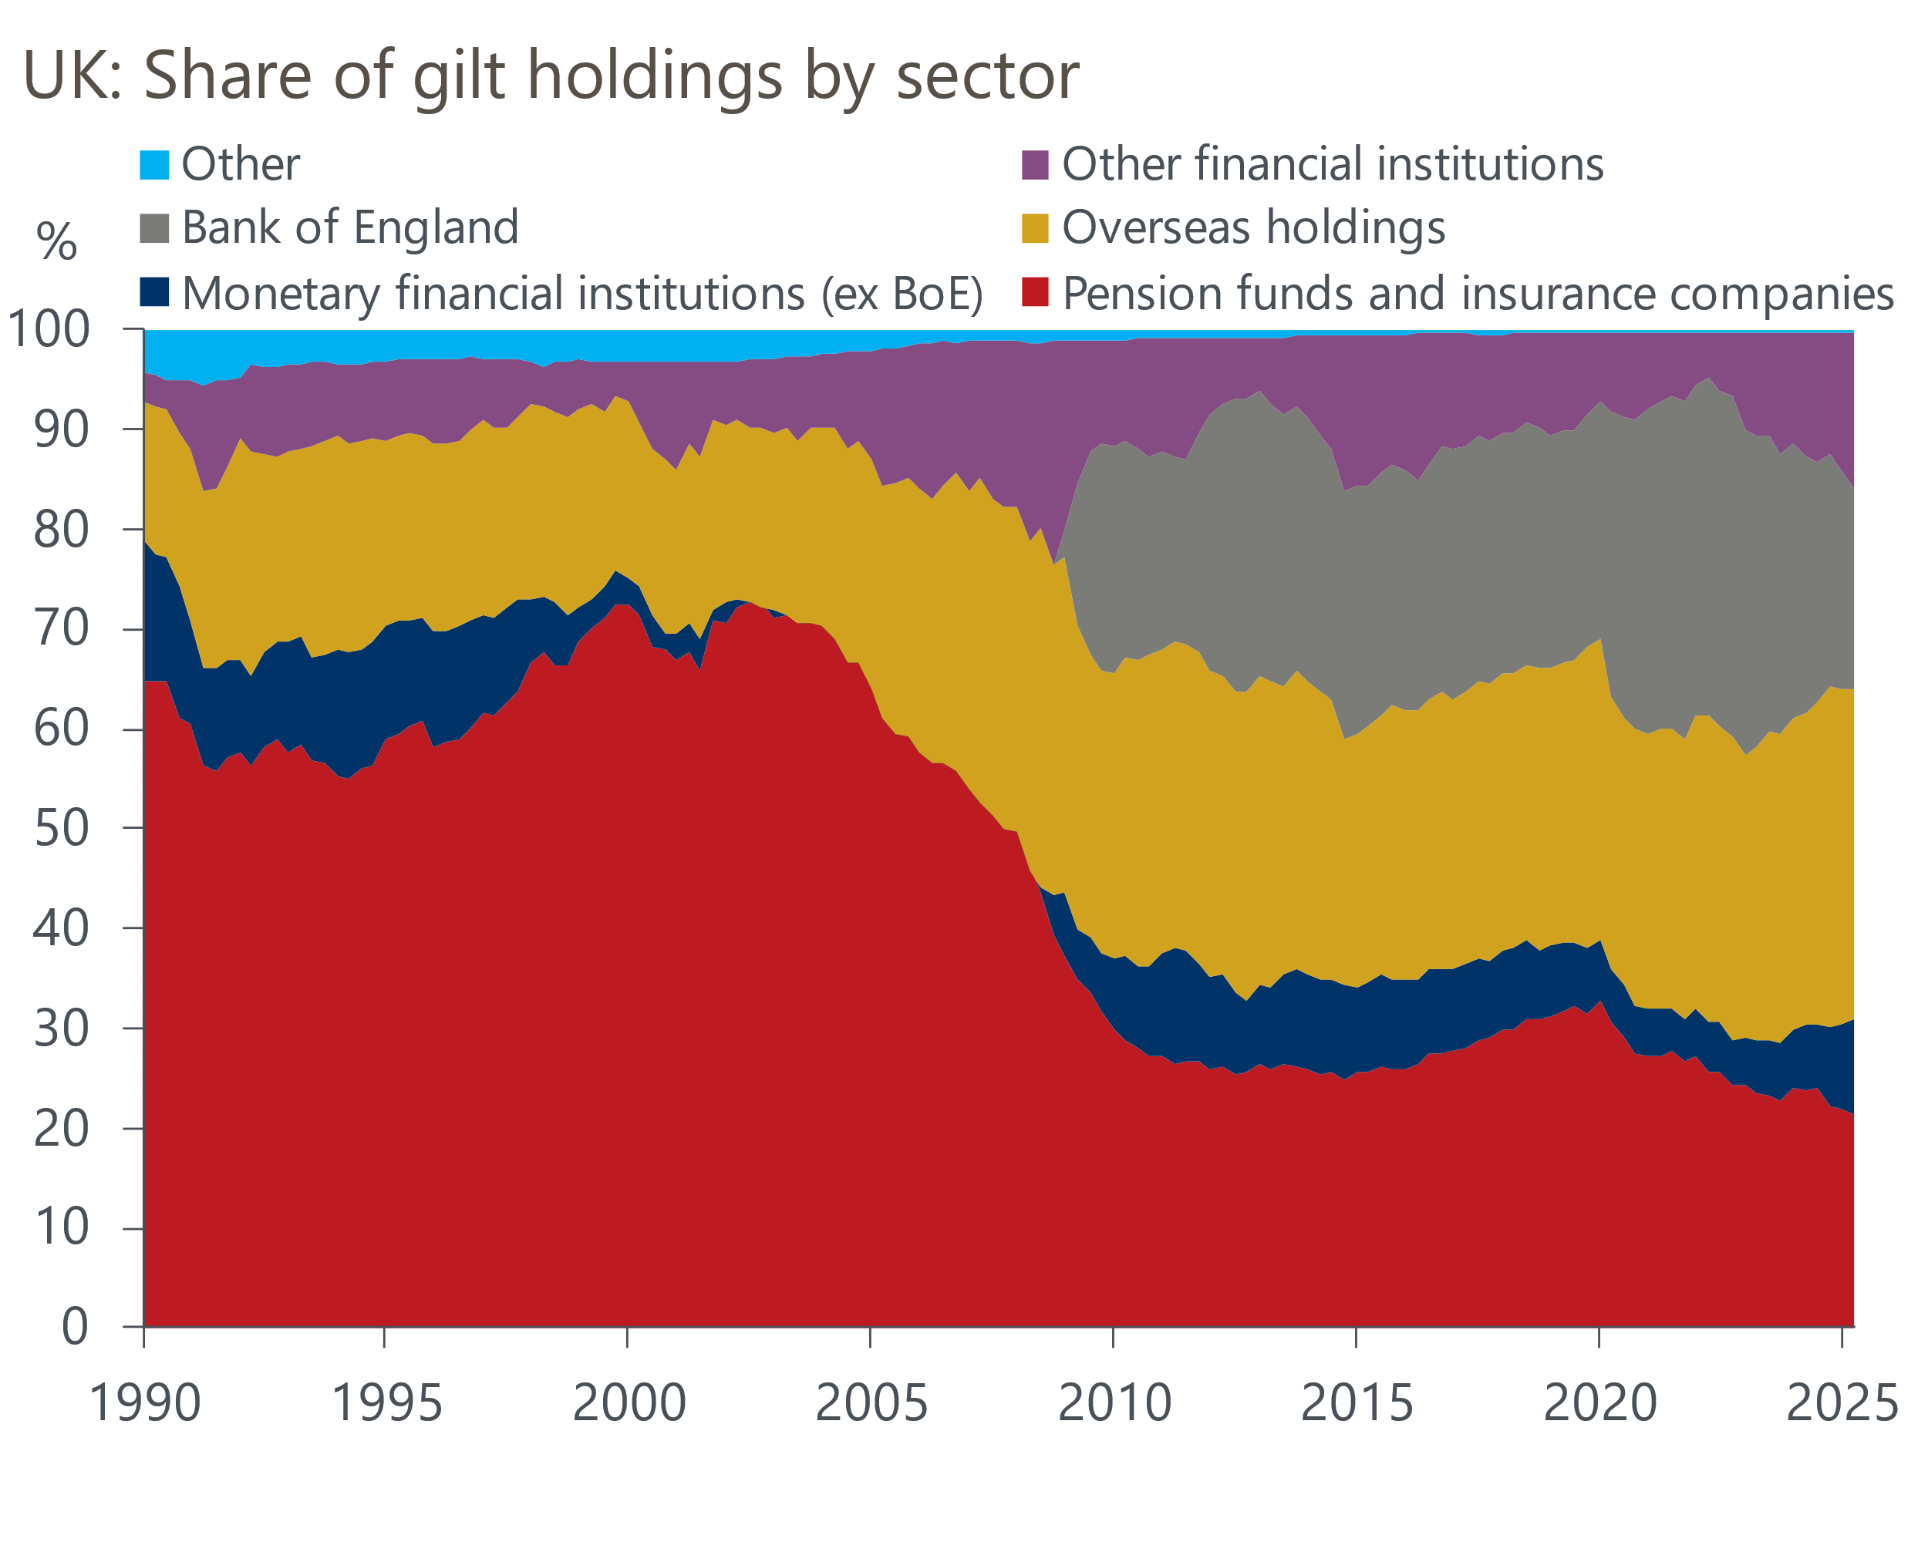
Sources: Debt Management Office
Although an ageing population might be expected to increase demand for long-duration safe assets, demographic shifts are unlikely to provide a tailwind for gilts. A growing proportion of DB pension schemes are now pursuing insurance buy-ins and buy-outs, where the majority of gilt holdings are divested in favour of alternative, higher-yielding assets. Meanwhile, the transition from DB schemes to defined contribution (DC) pension schemes, which tend to have portfolios dominated by equities, is likely to offset only a small fraction of the decline in gilts held by DB schemes.
Projections from the OBR's 2025 Fiscal Risks and Sustainability report estimate the overall pension sector's gilt holdings will fall from 29.5% of GDP in FY2024-2025 to just 10.9% of GDP in the medium term. This would represent a drop in gilt holdings of £518bn. The OBR's most optimistic scenario, which anticipates greater risk aversion supporting a high gilt allocation, still assumes a £410bn decline in holdings to 14.8% of GDP.
Weaker demand for gilts from UK pension funds has been replaced by increased holdings from other market participants. However, these investors appear on average to be flightier, favour shorter duration debt, and require additional yield to induce their demand as they have a wider choice of safe assets to select from.
As the government's fiscal position has deteriorated in recent years, gilt demand from domestic banks has risen considerably in the sub-15-year sector due to the relative attractiveness versus interest rate swaps (Chart 6). Demand from the retail sector and multi-asset investors has also picked up at the front end of the curve due to attractive yields and the tax efficiency of low-coupon gilts. Meanwhile, the presence of hedge funds in the gilt and gilt repo markets has risen in recent years as relative value strategies and cash-futures basis trades have grown in popularity.
Chart 6: Gilt yields have become more attractive relative to swaps in recent years
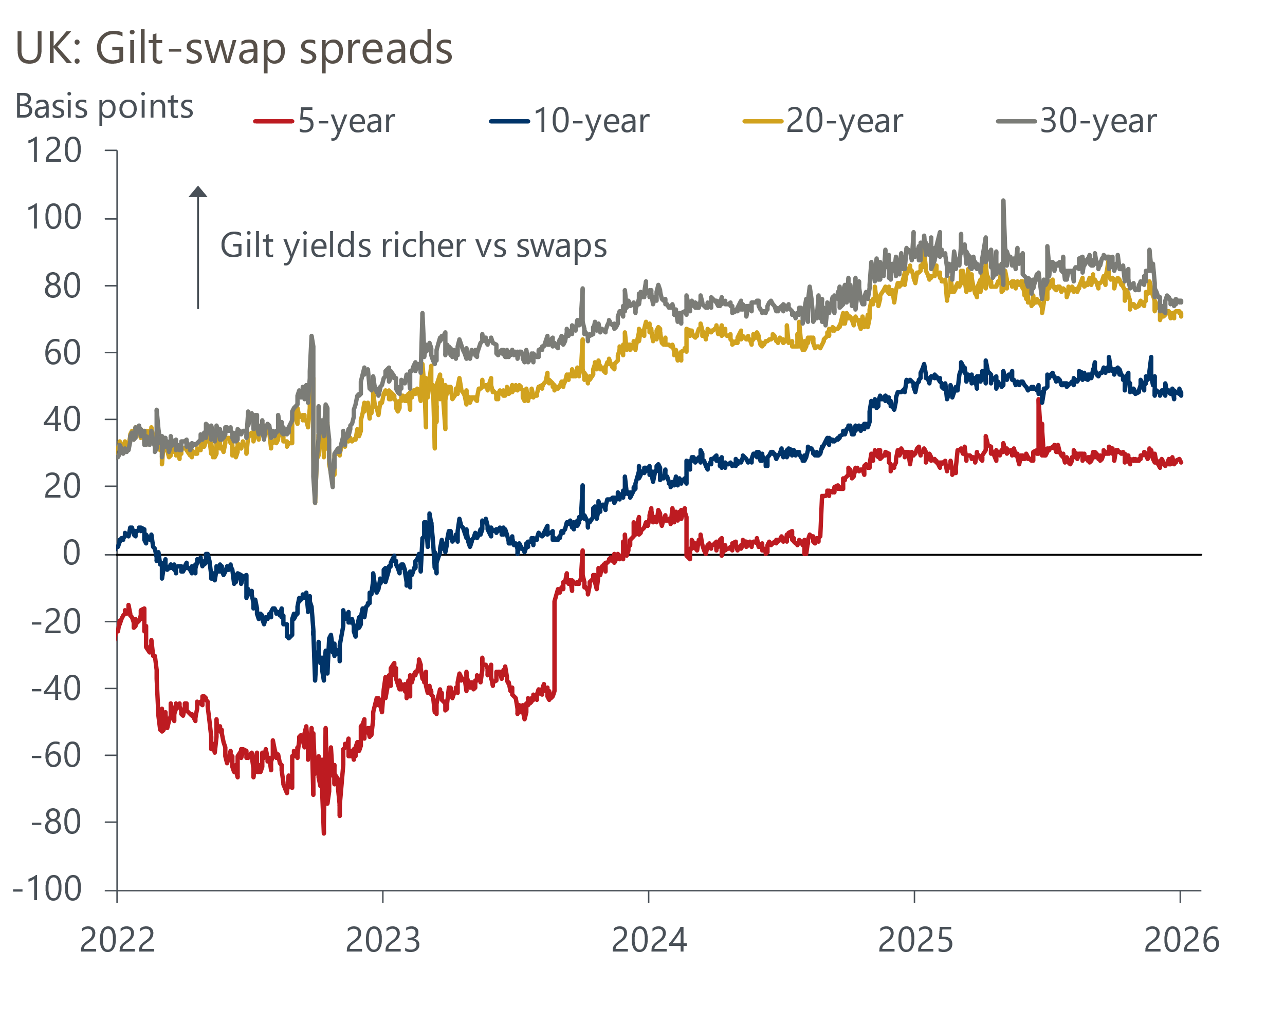
Source: Haver Analytics

The transition to a more fractured world will push up term premia
As we've previously argued, we appear to have entered into a new global economic paradigm, characterised by more frequent supply shocks and greater inflation and macroeconomic volatility. So investors are also requiring an additional return as compensation for bearing increased inflation risk and uncertainty.
In the past few years, the global economy has been hit by a series of major adverse supply shocks inflicted by the pandemic, supply-chain disruptions, and Russia's invasion of Ukraine. Though these may simply represent a run of unfortunate coincidences, we think it's more realistic to assume that the 2000-2019 period of low and very stable inflation was exceptional, and that some recent global trends may increase the likelihood of more adverse supply shocks over the next decade. These include the trend towards more populist governments, a fracturing in trading arrangements, climate change, and the complexity of modern global supply-chains.
While market pricing has started to adjust to the new economic paradigm, we think it has much further to go to fully incorporate these fundamental changes to the global inflation risk profile. Given the UK is a small open economy with an unusually high share of inflation-linked government debt, we think gilt term premia will be particularly susceptible as markets continue to price in the changing economic landscape.

Actions by the DMO and the BoE should help to alleviate some of these pressures
The Debt Management Office is well aware of these structural shifts in demand, and has responded to rising term premia by shifting supply away from longer duration gilts and indexed-linked gilts over the past decade. Similarly, the BoE announced in September that it will focus active gilt sales on shorter maturities.
The DMO's actions mean gilt issuance now has an average maturity of around 10 years, which is roughly half of the average maturity of the gilts issued in FY2015-2016. This has led to a significant shortening of the weighted average maturity of gilts, with the composition of the gilt market now closer to that of other G7 government bond markets. Though this means gilt issuance is becoming more sensitive to the interest rate cycle, which raises refinancing risks, the DMOs actions should help to better calibrate gilt supply to a more price-sensitive demand base.

Higher term premia puts the onus on government to deliver credible fiscal consolidation
Altogether, we think significantly higher issuance at a time of rising global safe asset supply, the marginal buyer of gilts becoming flightier and more price-sensitive, and a more volatile inflationary environment suggest we have entered a regime of structurally higher term premia (Chart 7). Therefore, the downward pressure on short-term rate expectations from weaker growth and inflation is likely to provide only a modest tailwind for gilts over the next couple of years.
Chart 7: UK term premia has risen sharply and is likely to remain elevated
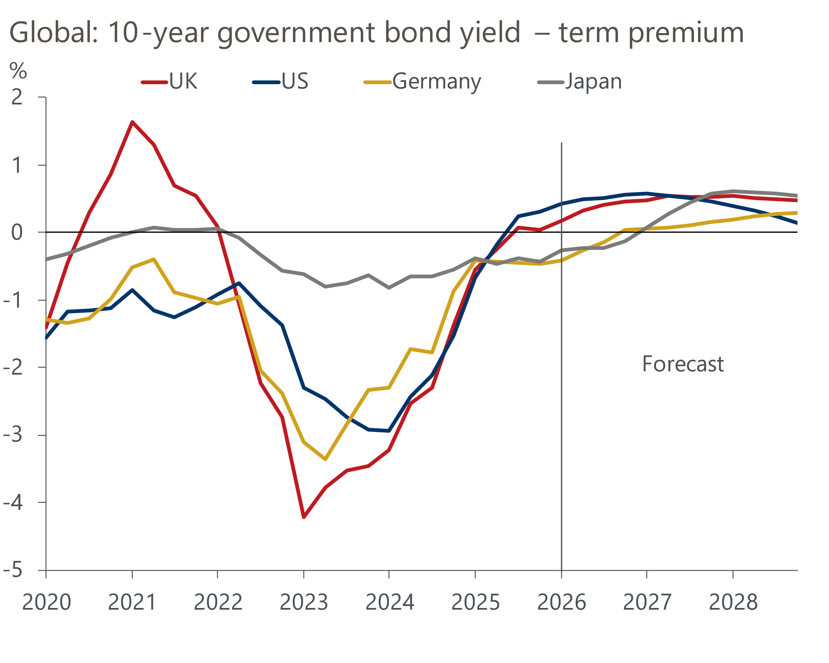
Sources: Oxford Economics
Although the financial market reaction to November's Budget was relatively muted, we expect markets to increasingly question the credibility of the package. In particular, we have concerns around the back-loaded nature of the measures, the uncertain impact on revenues of many of the narrower tax-raising measures, a lack of spending restraint, and the dearth of growth-enhancing policies. Consequently, we expect investors to pay very close attention to the UK's fiscal position and borrowing levels, and further policy missteps are likely to be punished far more swiftly than in the past.
For policymakers, this underlines the value of developing a clear and consistent fiscal strategy focused on delivering a credible path towards fiscal consolidation and removing long-discussed and politically challenging structural impediments to growth.

